**Initial Results**

The screen shot below is of the **flum.conf** file populated with my Twitter API developer key and token information. I have set HDFS as the sink for my live twitter stream and narrowed my selection down to all tweets with key words: Syria, refugee, Syrian Refugee, Syrian, Syrian refugee, Syrian Civil War, syrian crisis. I’ve accounted for case-sensitive variations of the key words as users may choose to tweet more casually in lower-case. I’ve created a folder in HDFS named /Newflumegrabber/RefugeeDatav0.1 for all the raw twitter data to load.

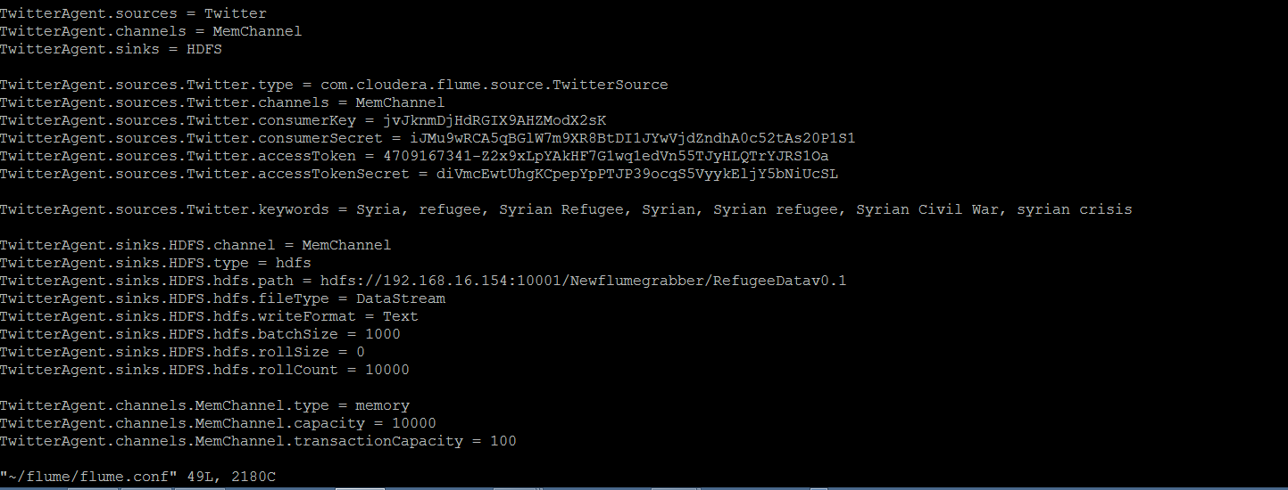

After running the scrape the data is loaded in blocks to the HDFS folder:

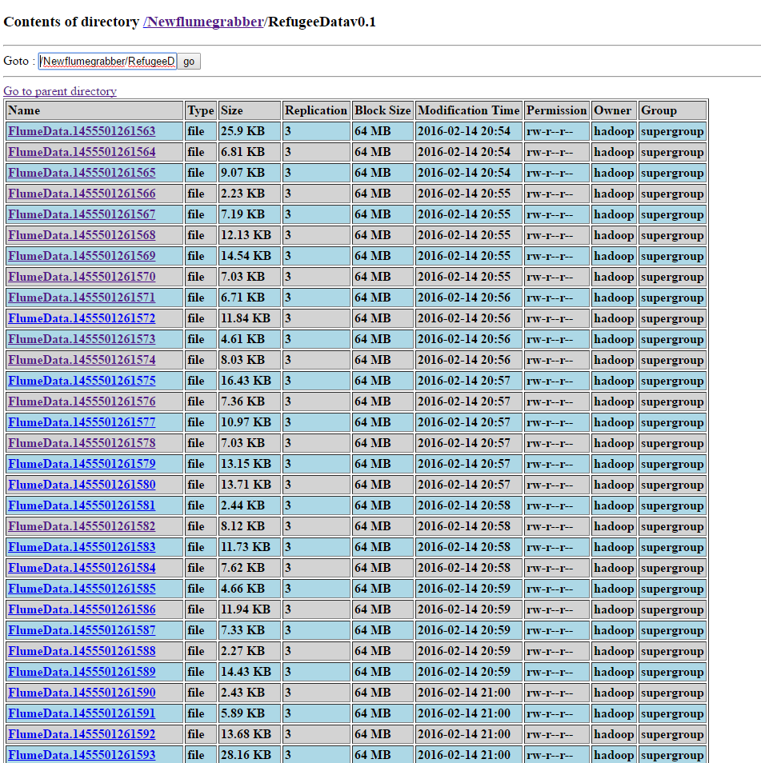

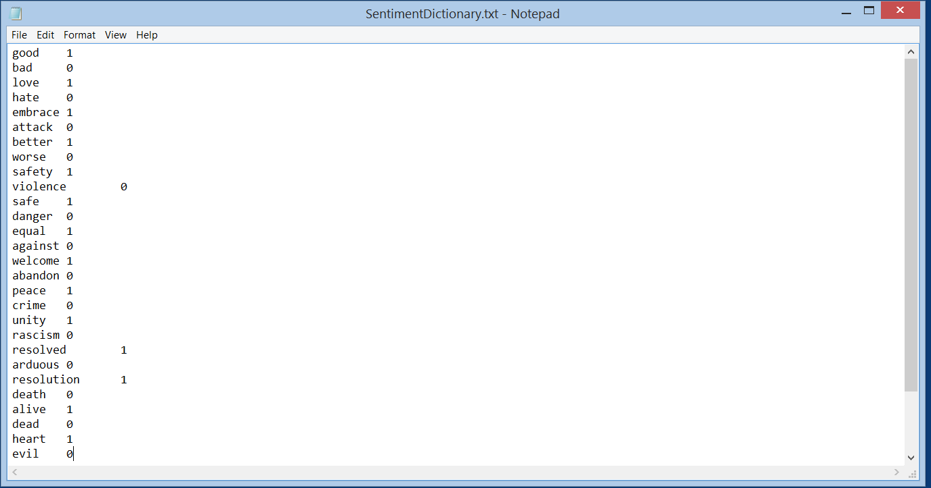I created a test Sentiment Dictionary, scoring positive words with a 1 and negative words with a 0, and loaded it into HDFS folder /user/lab.

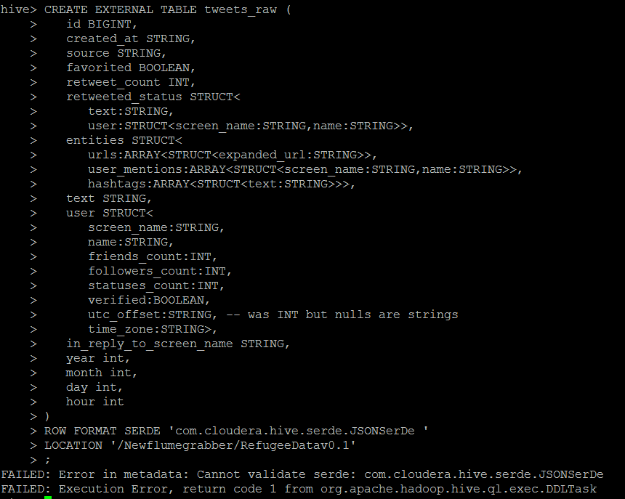I cannot get hive to read in the JSON twitter data. I have inputted hive-serdes-1.0.jar into /usr/local/hive/lib.